University of Technology, Jamaica
Faulty of Engineering and Computing
School of Computing and Information Technology
Advance Programming (CIT3009)
Raheem Olakunle (2304979), Davanea Morsby (2303839), Dantae Shirley (2304900), Tamai Richards (2301563)
Tutor: Christopher Panther
November 27, 2025

Relationships Overview
Customer → Shipment (1:M): A customer can send and receive multiple shipments. Each shipment has one sender and one recipient.
Shipment ↔ Vehicle (M:N via Assignment): Shipments can be transferred between vehicles. Multiple shipments can be assigned to multiple vehicles over time, resolved through the vehicle_shipments junction table.
Shipment → Invoice (1:1): Each shipment generates one invoice for billing purposes.
Invoice → Payment (1:M): An invoice can have multiple payments, supporting partial payment functionality.
Vehicle → Route (1:M): A vehicle can be assigned to multiple routes over time for delivery planning.
Driver ↔ Vehicle (1:1): Each driver can be assigned to one vehicle at a time.

Class Design
The object-oriented design maps directly to the database entities. The base class User is extended by specialized user roles (Customer, Clerk, Driver, Manager). Each shipment, vehicle, and payment is represented as a class with relevant attributes and methods.
User Inheritance Hierarchy

User

Customer Clerk Driver Manager

User (Base Class)
Purpose: Abstract base class for all system users.
Attributes: ID (int), Fname (String), Lname(String), email (String), passwordHash (String), salt (String)
Methods: setPassword(), verifyPassword()
Customer extends User
Attributes: custID (String), address(String), zone(int)
Relationships: Sends Shipments(1:M) & Receives Shipments(1:M)
Clerks extends User
Attributes: clkID (String)
Manager extends User
Attributes: mngID (String)
Driver extends User
Attributes: dln (String)
Relationships: Drives Vehicle (1:1)
Shipment
Attributes: trackingNumber (String), sender (Customer), recipent (Customer), weight (double), length (double), width (double), height (double): pType (PackageType enum): STANDARD, EXPRESS, FRAGILE, status (ShipmentStatus enum), shippingCost (double), createdDate (LocalDateTime), deliveredDate (LocalDateTime) statusListeners (List)
Methods: calculateShippingCost(), updateStatus()
Invoice
Attributes: invoiceNum(String), shipment(Shipment), senderId (String), receiptId (String), totalAmount (double), issueDate (LocalDateTime), dueDate(LocalDateTime), status (InvoiceStatus enum), payments (List<Payment>)
Methods: addPayment(), removePayment(), getTotalPaid(), getRemainingBalance(), updateInvoiceStatus()
Payment
Attributes: paymentId (int), amount (double), paymentDate (LocalDateTime), paymentMethod (PaymentMethod enum): CASH, CARD, status (PaymentStatus enum), referenceNumber (String), invoiceNum (String)
Methods: processPayment(), processCashPayment(), completeCashPayment()
Vehicle
Attributes: assignedDriver(Driver), licensePlate(String), vehicleType(String), maxWeightCapacity (double), maxPackageCapacity (int), currentWeight(double), currentPackageCount (int), isAvailable(boolean), assignedShipments(List<Shipment>)
Methods: canAddPackage(), assignShipment(), unassignShipment(), assignToRoute(), releaseFromRoute(), getUtilizationPercentage()
Route
Attributes: routeNum (String), vehicle (Vehicle), zone (int), shipments (List<Shipment>), startTime (LocalDateTime), endTime (LocalDateTime)
Methods: addShipment(), removeShipment(), startRoute(), endRoute(), getPlannedShipmentCount(), getTotalPlannedWeight()
From | To | Type | Cardinality | Description
User | Customer | Inheritance | 1:1 | IS-A relationship
User | Clerk | Inheritance | 1:1 | IS-A relationship
User | Manager | Inheritance | 1:1 | IS-A relationship
User | Driver | Inheritance | 1:1 | IS-A relationship
Customer | Shipment | Association | 1:M | Sends Shipment
Customer | Shipment | Association | 1:M | Receive Shipment
Shipment | Invoice | Association | 1:M | Generates Invoices
Invoice | Payment | Composition | 1:M | Contains Payments
Driver | Vehicle | Association | 1:1 | Drives Vehicle
Vehicle | Shipment | Association | 1:M | Carries Shipments
Vehicle | Route | Association | 1:1 | Runs Route
Route | Shipment | Association | 1:M | Includes Shipments
Vehicle | ShipmentStatusListener | Realization |  | Implements interface
Shipment | ShipmentStatusListener | Dependency |  | Notifies listeners

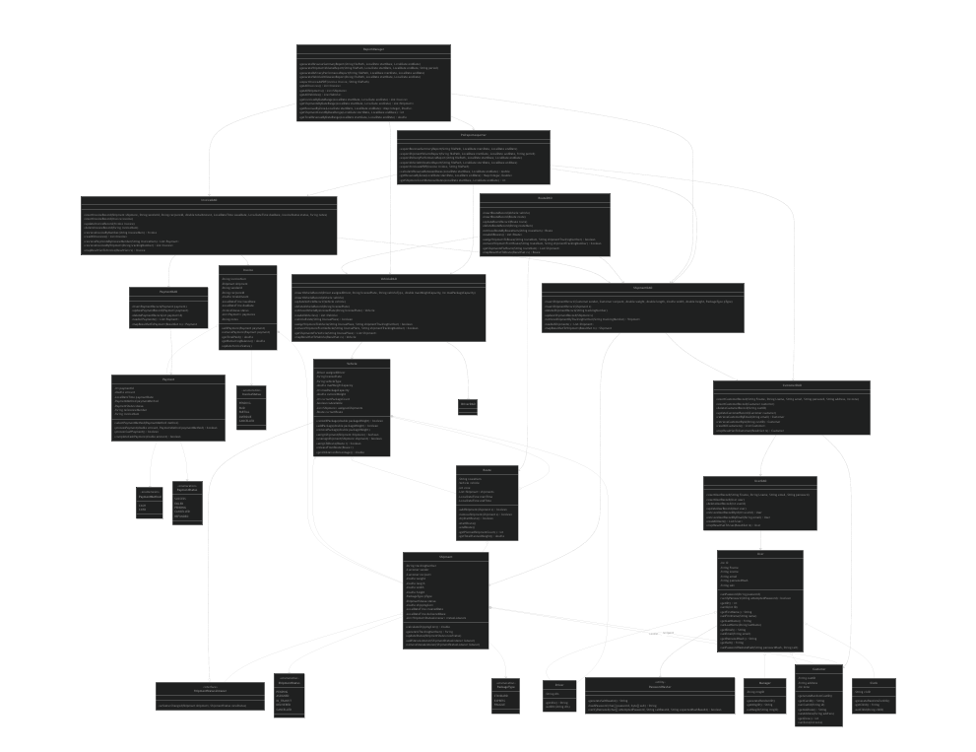
Database Normalization (3NF)
First Normal Form (1NF): All attributes are atomic and have unique column names. For example, shipment dimensions are stored as separate columns (length, width, height) rather than a composite value.
Second Normal Form (2NF): Non-key attributes fully depend on the entire primary key. The vehicle_shipments and route_shipments junction tables use composite primary keys with no partial dependencies.
Third Normal Form (3NF): No transitive dependencies exist; non-key fields depend only on the primary key. Customer address is stored in the customer table and referenced via foreign key in shipment , preventing transitive dependencies like trackingNumber → senderId → address. Therefore, the database design is in 3NF, ensuring no redundancies and maintaining referential integrity.
Entity- Relationship Diagram (ERD)
user: ID (PK, Auto-increment), Fname, Lname, email (UNIQUE), password, salt
customer: custID (PK), UserID (FK → user.ID, UNIQUE), address,zone
clerk: clerkID (PK), UserID (FK → user.ID, UNIQUE)
manager: mngID (PK), UserID (FK → user.ID, UNIQUE)
driver: dln (PK), UserID (FK → user.ID, UNIQUE)
shipment: trackingNumber (PK),senderId (FK → customer.custID), recipentId (FK → customer.custID), weight, length, width, height, PackageType (ENUM: STANDARD, EXPRESS, FRAGILE), ShipmentStatus (ENUM: PENDING, ASSIGNED, IN_TRANSIT, DELIVERED, CANCELLED), shippingCost, createdDate, deliveredDate
vehicle: licensePlate (PK), vehicleType, maxWeightCapacity, maxPackageCapacity, driversLicense (FK → driver.dln, NULLABLE), currentWeight, currentPackageCount, isAvailable
route: routeNum (PK), VehiclePlateNum (FK → vehicle.licensePlate), zone, startTime, endTime
invoice: invoiceNum (PK), shipment_trackingNumber (FK → shipment.trackingNumber), senderId (FK → customer.custID), recipentId (FK → customer.custID), totalAmount, issueDate, dueDate, InvoiceStatus (ENUM: PENDING, PAID, PARTIAL, OVERDUE, CANCELLED), notes
payment: paymentId (PK, Auto-increment), amount, paymentDate, PaymentMethod (ENUM: CASH, CARD), PaymentStatus (ENUM: SUCCESS, FAILED, PENDING, CANCELLED, REFUNDED), referenceNumber, invoiceNum (FK → invoice.invoiceNum, CASCADE DELETE)
Junction Tables (M:N Resolution)
vehicle_shipments
licensePlate (PK, FK → vehicle.licensePlate)
shipmentTrackingNumber (PK, FK → shipment.trackingNumber)
route_shipments
routeNum (PK, FK → route.routeNum)
shipmentTrackingNumber (PK, FK → shipment.trackingNumber)
